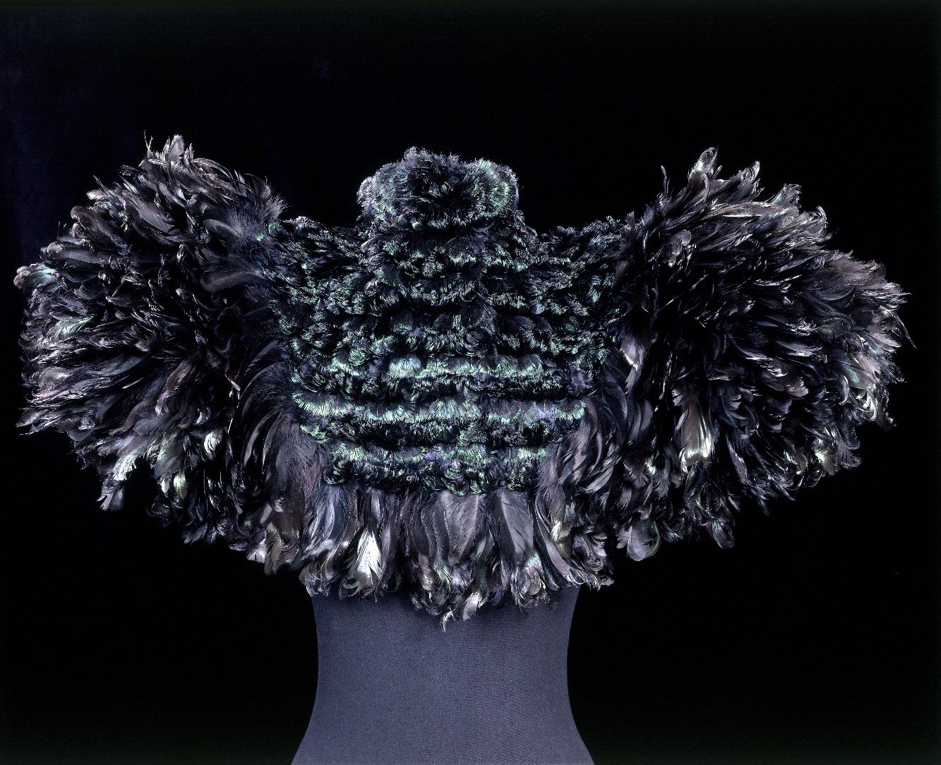
Fashioned From Nature
April 21 2018 – January 27 2019
Cape of curled cockerel feathers, Auguste Champot, about 1895, France. Museum no. T.84-1968. © Victoria and Albert Museum, London
From a pineapple fibre clutch-bag to a cape of cockerel feathers, the V&A’s forthcoming fashion exhibition will trace the complex relationship between fashion and the natural world since 1600 to the present day. Showcasing over 300 objects, including exquisite garments and accessories by Christian Dior, Dries van Noten and Philip Treacy, Fashioned from Nature will present fashionable dress alongside natural history specimens, innovative new fabrics and dyeing processes, inviting visitors to think about the materials of fashion and the sources of their clothes.
Free to Members of the AFV&A and V&A (£12 for non-members)
Saturday-Thuursday: 10.00-17.30
Friday: 10.00-21.30
Room 40, Fashion

